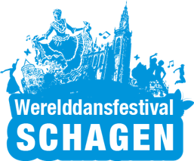 | Werelddansfestival  Schagen

Participation Application form

Group Information
Full name of the group:

Art director:

Group leader:

Artistic category:

Address:
 | Street Address | Number

 | City | State/Province | ZIP Code

Phone: |  | Email:
Mobile:

Group Description
Foundation:

Special aspects of your group (dances, instruments, costumes):

Experiences:

Did you organize a festival? |  | YES | NO
If yes, explain:

Other group information:

References
Please list any recent festivals (in Europe).
Videos (for example, links to YouTube movies).
Please add some photos of your group performances to your application. (attached to the email sending this from)

Composition of your group

 | Age | < 16 Years | 16<18 Years | 18<40 Years | > 40 Years | Total
Dancers | Male
 | Female
Musicians | Male
 | Female
Singers | Male
 | Female
Directors | Male
 | Female
Drivers | Male
 | Female
Others? | Male
 | Female
Total
Please note:
- The participation of young members below the age of 18, must be accepted by the organizer.
- We prefer groups of approximately 30 persons.

Other information

Please add other important information that we should know as organizer of the festival. For example, special food requirements, state of health of group members or officials.

Other comments:

Do you accept the Participation Rules? | YES  ☐ | NO  ☐

Disclaimer and Signature
I certify that my answers are true and complete to the best of my knowledge.
Signature: |  | Date:

Please be aware: when you submit your application, we do not guarantee any approval.
We will contact you within one month after your application.

